

Fifth Sunday of Easter

CHRIST LUTHERAN CHURCH | Lodi, California
May 3, 2026

WELCOME TO WORSHIP
Welcome to Christ Lutheran Church. We pray that your soul will be strengthened by the good news about God’s grace, love, and forgiveness given to us. If you would like to learn more about our church, please speak with our pastor or one of our members after the service.
- Bathrooms are located in the fellowship hall. A changing table is located in the women’s bathroom.
WORSHIP THEME
The Easter gift of a foundation. Christ is the Way, the Truth, and the Life. He is the only name given to us that will bring salvation. Apart from him, we are wandering. But if we build upon him, we will find what we need for life and eternity.

The Service, Setting I
The high and holy worship of God is faith in Jesus Christ. Such faith is created and sustained by God’s service to us (the German, “Gottesdienst,” “The Divine Service”). In the Divine Service, the Lord comes to us in His Word and Sacrament to bless and enliven us with His gifts. The Service is not something we do for God, but His service to us received in faith. The liturgy is God’s work. He gives, we receive.
HYMN Welcome Happy Morning| CW 469
M: In the name of the Father, and of the Son, and of the Holy Spirit.
C: Amen.

CONFESSION
From God’s Word we know that wherever God puts His name, there He is to bless. In the Old Testament the temple was the place where God graciously caused His name to be present (1 Kings 8:27-30).
God has put His name —Father, Son, and Holy Spirit—on us in Holy Baptism. The Divine Service begins with the Invocation, the words spoken over us at our baptisms. Every Divine Service is for the hallowing of the Lord’s name, which the Small Catechism reminds us is done “when the Word of God is taught in its truth and purity, and we, as the children of God, also lead holy lives according to it” (Matthew 28:18-20).
M: Beloved in the Lord: let us draw near with a true heart and confess our sins to God our Father, asking him in the name of our Lord Jesus Christ to grant us forgiveness.
C: Holy and merciful Father, I confess that I am by nature sinful, and that I have disobeyed you in my thoughts, words, and actions. I have done what is evil and failed to do what is good. For this I deserve your punishment both now and in eternity. But I am truly sorry for my sins, and trusting in my Savior Jesus Christ, I pray: Lord, have mercy on me, a sinner.

absolution
M: God, our heavenly Father, has been merciful to us and has given his only Son to be the atoning sacrifice for our sins. Therefore, as a called servant of Christ and by his authority, I forgive you all your sins in the name of the Father and of the Son ✙ and of the Holy Spirit.
C: Amen

Kyrie
M: In peace let us pray to the Lord.
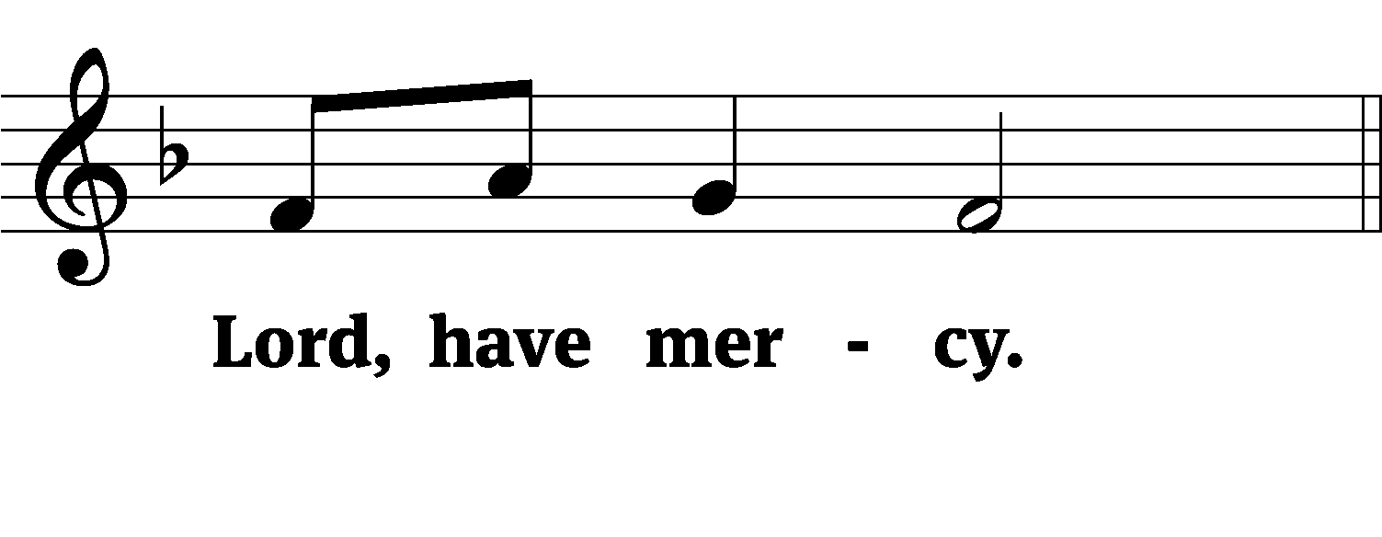
M: For the peace from above and for our salvation, let us pray to the Lord.
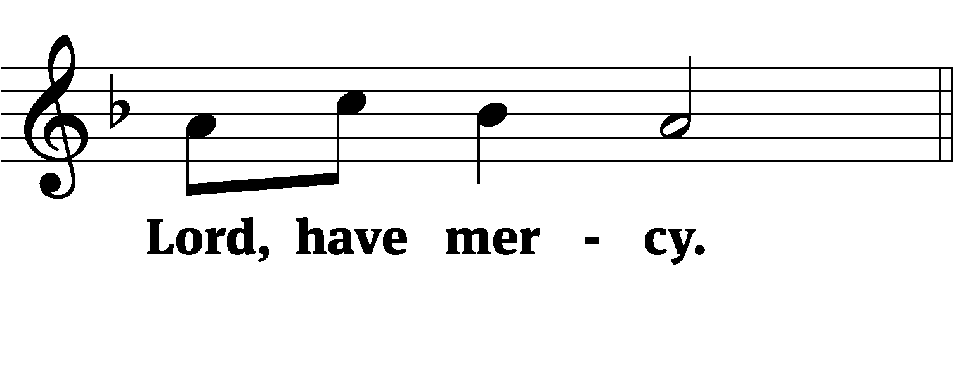
M: For the peace of the whole world, for the well-being of the Church of God, and for the unity of all, let us pray to the Lord.
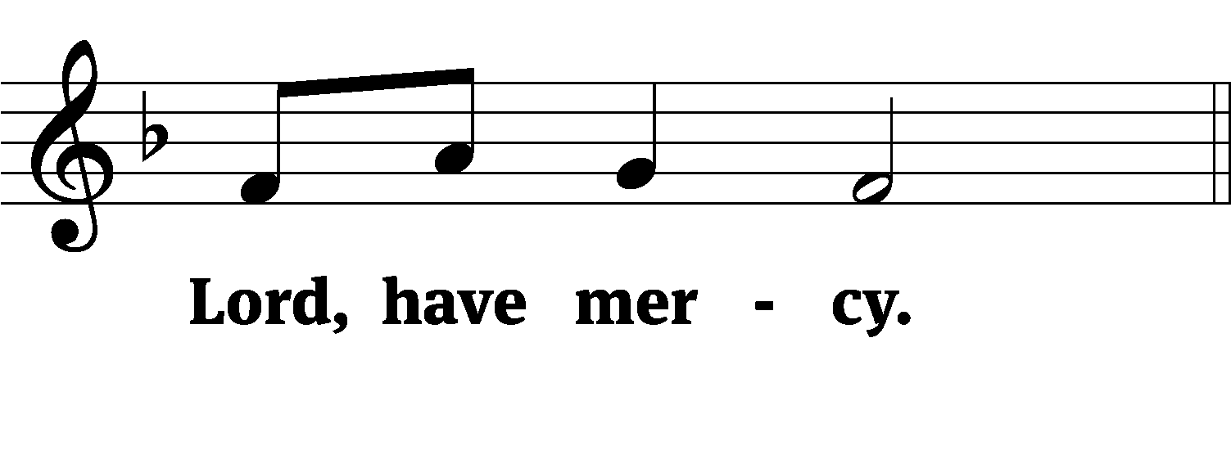
M: For this holy house and for all who offer here their worship and praise, let us pray to the Lord.
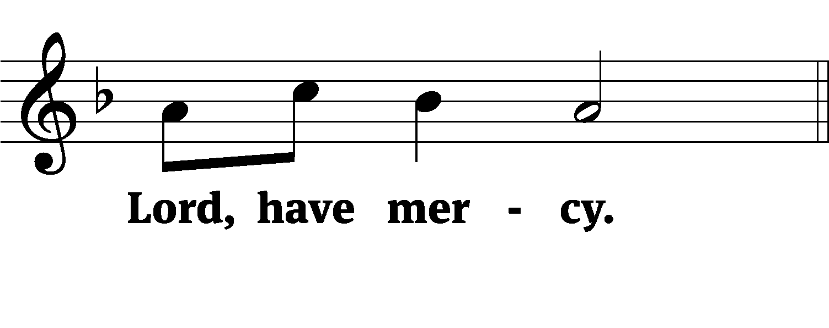
M: Help, save, comfort, and defend us, gracious Lord.
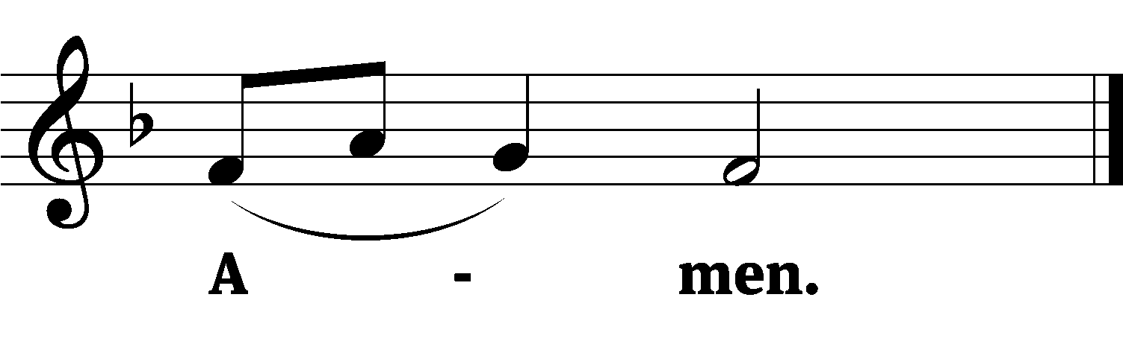

M: Let us praise the Lord.
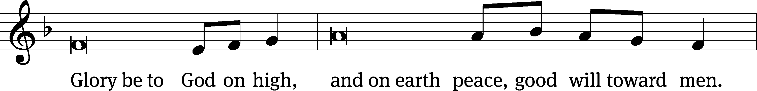
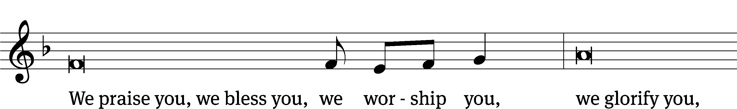
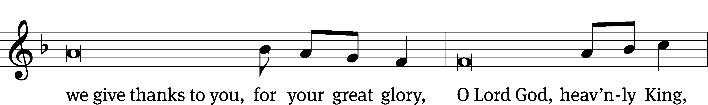
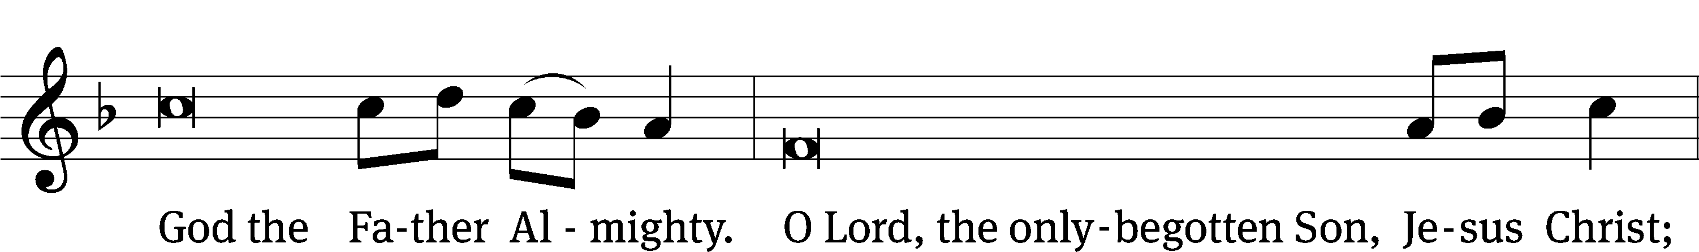
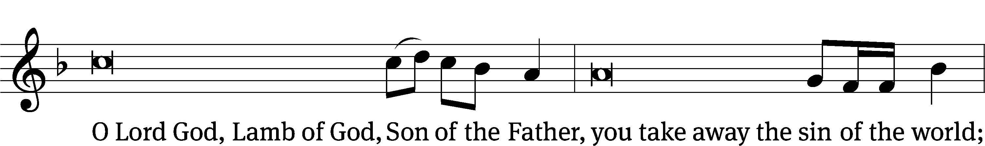
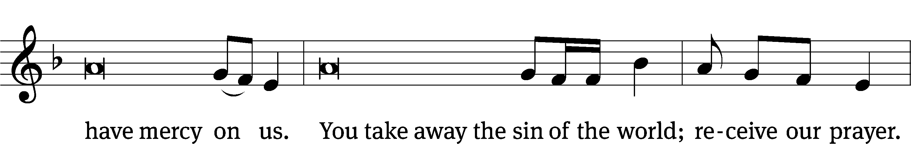
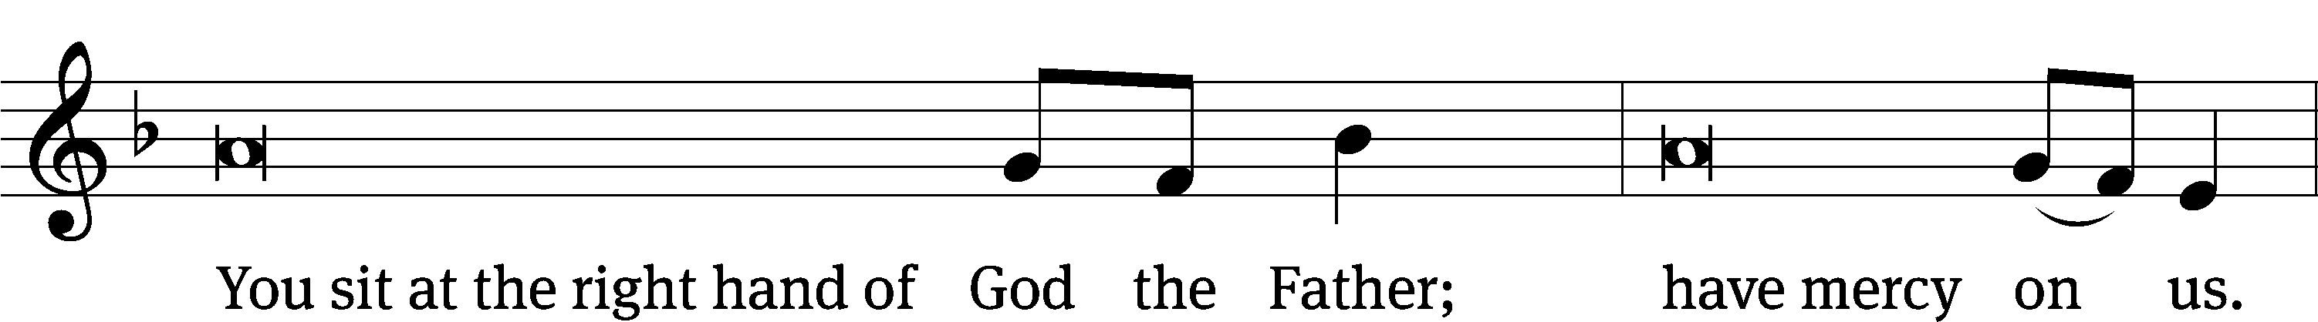
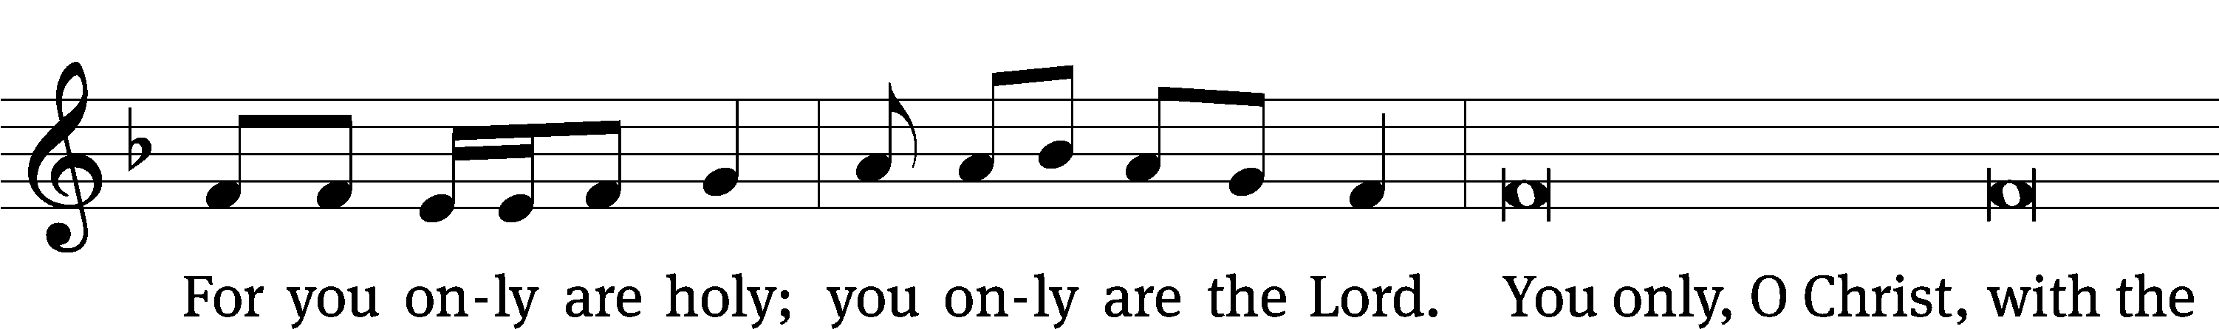
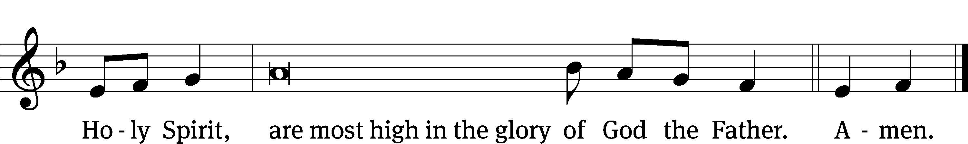
PRAYER OF THE DAY
M: The Lord be with you.
C: And also with you.
M: Let us pray.
O God, you form the minds of your faithful people into a single will. Make us love what you command and desire what you promise, that among the many changes of this world, our hearts may ever yearn for the lasting joys of heaven; through your Son, Jesus Christ our Lord, who lives and reigns with you and the Holy Spirit, one God, now and forever.
C: Amen
FIRST LESSON Acts 4:8–12
The Apostles proclaim the centrality of Christ.
Then Peter, filled with the Holy Spirit, said to them: “Rulers and elders of the people! If we are being called to account today for an act of kindness shown to a man who was lame and are being asked how he was healed, then know this, you and all the people of Israel: It is by the name of Jesus Christ of Nazareth, whom you crucified but whom God raised from the dead, that this man stands before you healed. Jesus is
“‘the stone you builders rejected,
which has become the cornerstone.’
Salvation is found in no one else, for there is no other name under heaven given to mankind by which we must be saved.”
PSALM Psalm 118
SECOND LESSON 1 Peter 1:3–9
We build on Christ and find our identity in him.
As you come to him, the living Stone—rejected by humans but chosen by God and precious to him— you also, like living stones, are being built into a spiritual house to be a holy priesthood, offering spiritual sacrifices acceptable to God through Jesus Christ. For in Scripture it says:
“See, I lay a stone in Zion,
a chosen and precious cornerstone,
and the one who trusts in him
will never be put to shame.”
Now to you who believe, this stone is precious. But to those who do not believe,
“The stone the builders rejected
has become the cornerstone,”
and,
“A stone that causes people to stumble
and a rock that makes them fall.”
They stumble because they disobey the message—which is also what they were destined for.
But you are a chosen people, a royal priesthood, a holy nation, God’s special possession, that you may declare the praises of him who called you out of darkness into his wonderful light. Once you were not a people, but now you are the people of God; once you had not received mercy, but now you have received mercy.
VERSE OF THE DAY John 14:6
M: Alleluia, Alleluia. Christ is risen!
C: He is risen, indeed! Alleluia!
M: I am the way and the truth and the life. No one comes to the Father except through me.
C: Alleluia.
THE GOSPEL John 14:1–11
Christ brings comfort to his disciples: he is the Way, the Truth, and the Life.
“Do not let your hearts be troubled. You believe in God; believe also in me. My Father’s house has many rooms; if that were not so, would I have told you that I am going there to prepare a place for you? And if I go and prepare a place for you, I will come back and take you to be with me that you also may be where I am. You know the way to the place where I am going.”
Thomas said to him, “Lord, we don’t know where you are going, so how can we know the way?”
Jesus answered, “I am the way and the truth and the life. No one comes to the Father except through me. If you really know me, you will know my Father as well. From now on, you do know him and have seen him.”
Philip said, “Lord, show us the Father and that will be enough for us.”
Jesus answered: “Don’t you know me, Philip, even after I have been among you such a long time? Anyone who has seen me has seen the Father. How can you say, ‘Show us the Father’? Don’t you believe that I am in the Father, and that the Father is in me? The words I say to you I do not speak on my own authority. Rather, it is the Father, living in me, who is doing his work. Believe me when I say that I am in the Father and the Father is in me; or at least believe on the evidence of the works themselves.
M This is the Gospel of the Lord.
C: Praise be to you, O Christ!

NICENE CREED
We believe in one God, Dt. 6:4
the Father, the Almighty, 2 Cor. 6:18
maker of heaven and earth, Is. 51:13
of all that is, seen and unseen. Col. 1:16
We believe in one Lord, Jesus Christ, 1 Cor 8:6
the only Son of God, Jn. 3:16
eternally begotten of the Father, Heb. 1:2,5
God from God, Light from Light, true God from true God, Jn. 1
The Nicene Creed is the great Confession of the Christian faith professed by all Christians. The Creed originated at the First Council of Nicaea (c. AD. 325)
begotten, not made, of one being with the Father. Jn. 10:30
Through him all things were made. Jn. 1:3
For us and for our salvation, 1 Th. 5:9
he came down from heaven, Jn. 6:38
was incarnate of the Holy Spirit and the virgin Mary, Lk. 1:35
and became fully human. Gal. 4:4
For our sake he was crucified under Pontius Pilate. Mk. 15:15
He suffered death and was buried. 1 Cor. 15:3-4a
On the third day he rose again in accordance
with the Scriptures. 1 Cor. 15:4b
The Creed itself was crafted as a confession of Scripture in opposition to the Arian heresy, which denied that the Lord Jesus and the Holy Spirit are God.

He ascended into heaven Ac. 2:33-34
and is seated at the right hand of the Father. Heb. 1:13
He will come again in glory Mt. 25:31
to judge the living and the dead, 2 Tim. 4:1
and his kingdom will have no end. Lk. 1:33
We believe in the Holy Spirit, the Lord, the giver of life, Job 33:4
who proceeds from the Father and the Son, Jn. 15:26
who in unity with the Father and the Son Jn. 4:24
is worshiped and glorified,
who has spoken through the prophets. 2 Pet. 1:25
We believe in one holy Christian Mt. 16:18; Eph. 2:19-20
and apostolic Church.
We acknowledge one baptism for the forgiveness of sins. Eph. 4:5; Ac. 2:38
We look for the resurrection of the dead 1 Cor. 15:21-22
and the life of the world to come. Amen. Rev. 22
HYMN OF THE DAY Do Not Let Your Hearts Be Troubles| CW 809
SERMON Acts 4

OFFERTORY
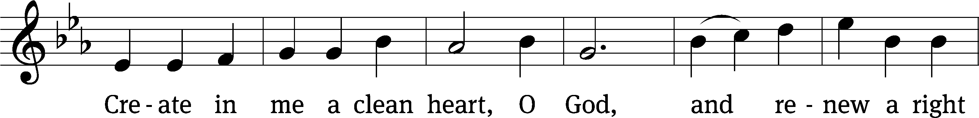
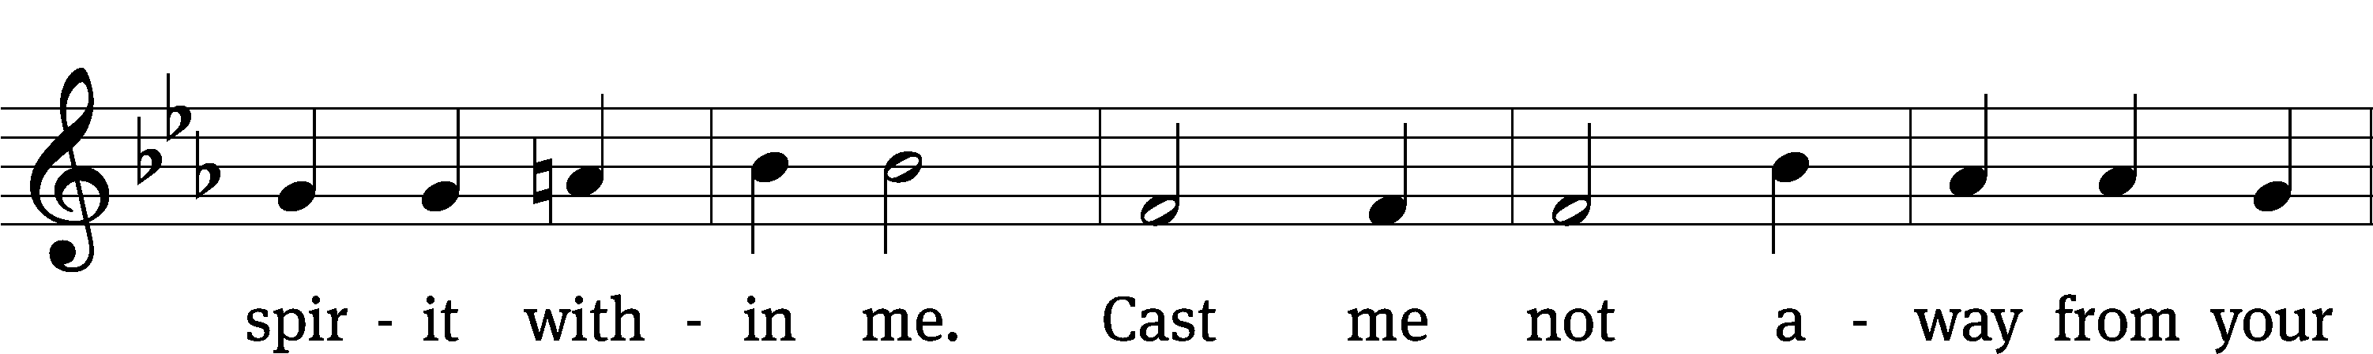
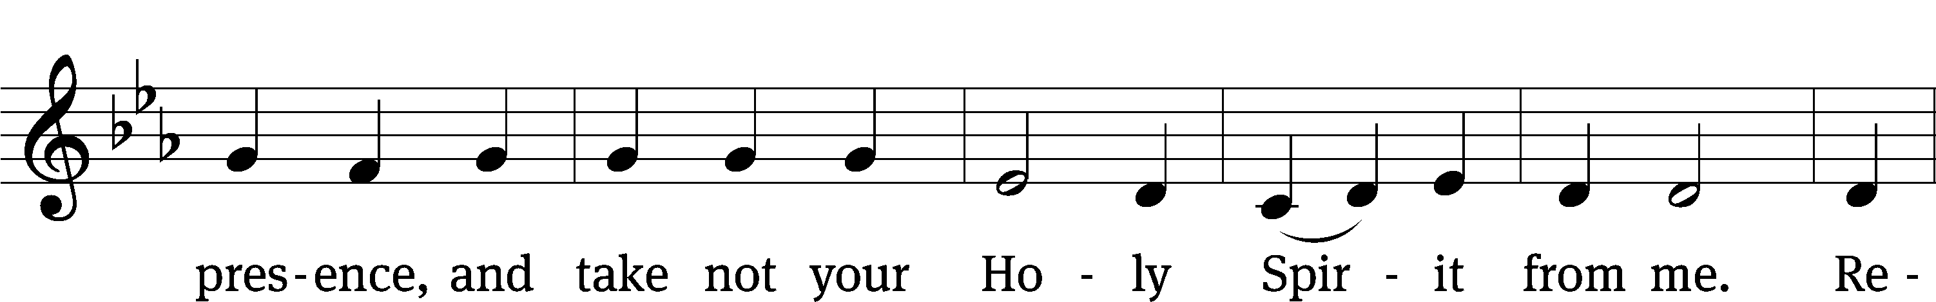
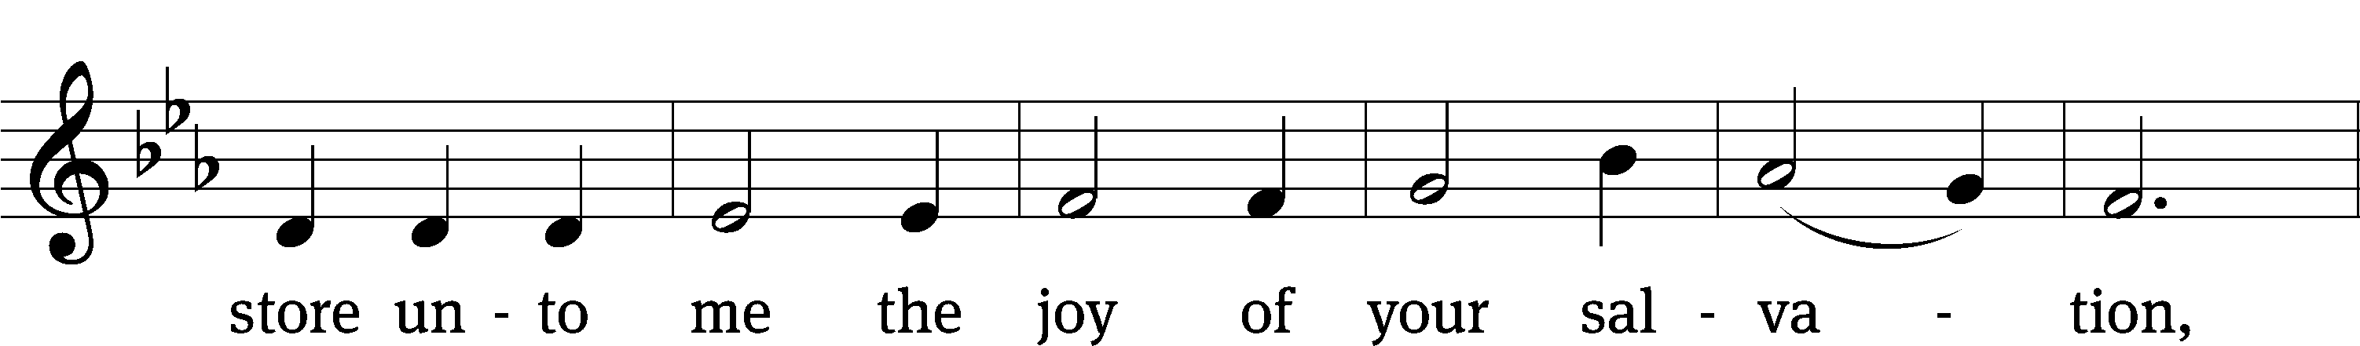
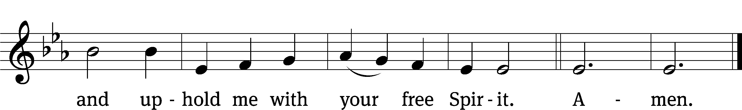
OFFERING
In response to God’s love and forgiveness, we give back a portion of what he has given us. The members of Christ Lutheran Church have joined to proclaim the gospel to this community. These offerings support that work. While our guests are welcome to participate, they should not feel obligated to do so.
PRAYER OF THE CHURCH
M: Heavenly Father, through the power of Christ’s resurrection You adopt all who believe in Him. Receive us as Your newborn children and nourish our faith through the pure spiritual milk of Your Word, that we may dwell in Your presence forever. Lord, in Your mercy,
C: Hear our prayer.
M: Send laborers into Your harvest, Lord. Preserve Your ministers among us devoted to Your Word and to prayer. Give many servants to Your Church, that neither the preaching nor the care of Your people may fall into neglect or disregard. Lord, in Your mercy,
C: Hear our prayer.
M: Merciful Lord, help parents to raise up their children to know You as their help and hope, that they may not put their trust in princes in whom there is no salvation. Lord, in Your mercy,
C: Hear our prayer.
M: Holy God, Your power brought all things into being and still preserves what You have made. Bless Donald, our president; the Congress of the United States; Gavin, our governor; and all elected and appointed civil servants. Lead them to honor You and Your purpose, establishing order and justice, encouraging virtue, and protecting all life. Give them wisdom and moderation to lead for the well-being of the nation. Lord, in Your mercy,
C: Hear our prayer.
M: Father of glory, Your Son declared Himself to be the way, the truth and the life. Bless all who have requested our prayers [especially _____________]. May Christ Himself be their way of salvation, their truth amid doubt and their life amid death. Grant them a sure and steadfast hope in the good news that He has prepared a place for them with You, where pain and sickness are no more and all things are made new. Lord, in Your mercy,
C: Hear our prayer.
M: Almighty God, in Christ You have made us a chosen race, a royal priesthood, a holy nation and a people for Your possession. Preserve Your people in the one true faith, and grant that all who come to the Supper this day might do so with repentant hearts that thankfully receive Your Son’s body and blood. Lord, in Your mercy,
C: Hear our prayer.
M: Graciously receive our prayers, deliver and preserve us, for to You alone we give all glory, honor and worship, Father, Son and Holy Spirit, one God, now and forever.
C: Amen.

LORD’S PRAYER Matthew 6:9-13; Luke 11:2-4
C: Our Father who art in heaven,
hallowed be thy name,
thy kingdom come,
thy will be done on earth as it is in heaven.
Give us this day our daily bread;
and forgive us our trespasses,
as we forgive those
who trespass against us;
and lead us not into temptation,
but deliver us from evil.
For thine is the kingdom, and the power,
and the glory forever and ever. Amen.

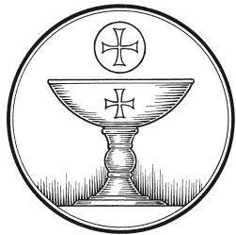
The Service of the Sacrament
This greeting marks a new service, so to speak. These ancient introductory words & phrases help to highlight, celebrate and bring attention to the Sacrament.
M: The Lord be with you.
C: And also with you.
M: Lift up your hearts.
C: We lift them up to the Lord.
M: Let us give thanks to the Lord our God.
C: It is good and right so to do.
M: It is truly good and right that we should at all times and in all places give you thanks, O Lord, holy Father, almighty and everlasting God, through Jesus Christ, our Lord, who by his willing sacrifice on the cross took away the sins of the world, and by his glorious resurrection restored everlasting life. Therefore with all the saints on earth and hosts of heaven, we praise your holy name and join their glorious song:

HOLY, HOLY, HOLY – Sanctus
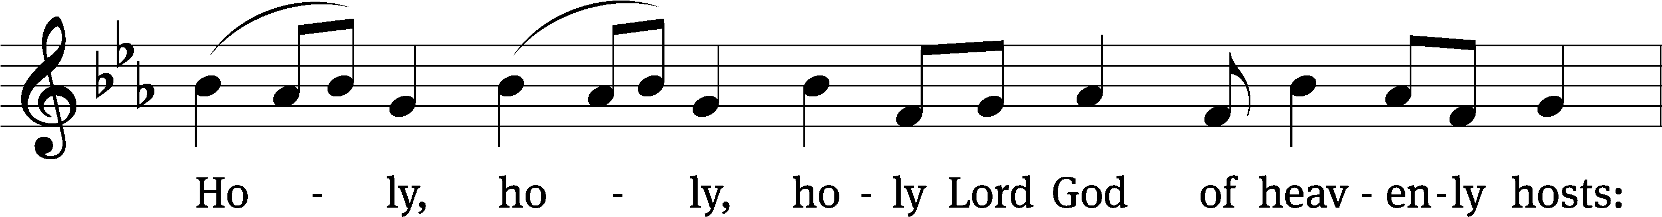
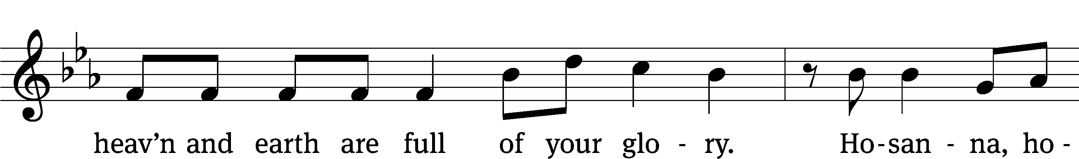
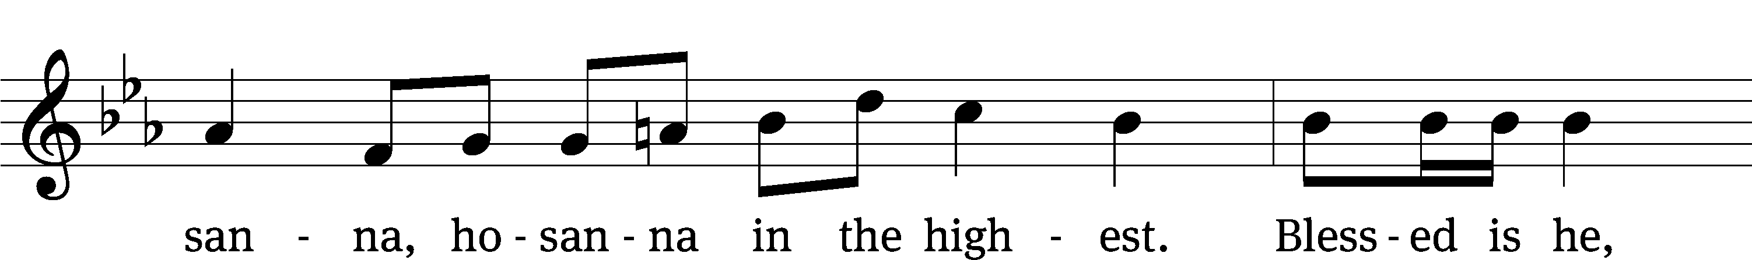
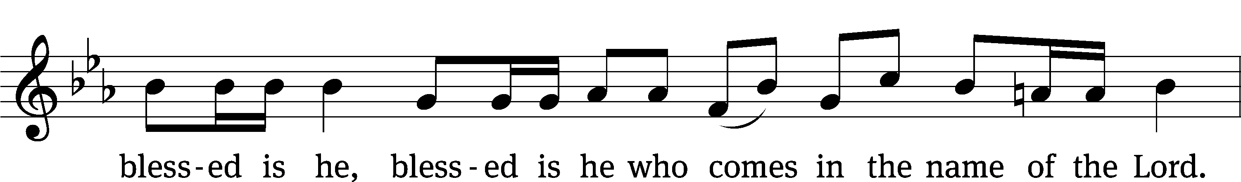
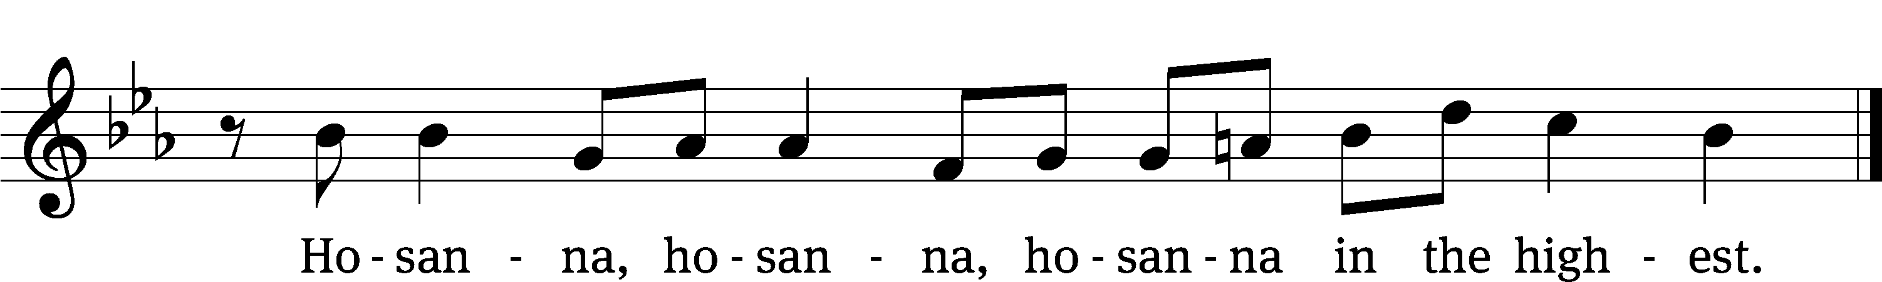
WORDS OF INSTITUTION Matthew 26, Mark 14, Luke 22
M: Our Lord Jesus Christ, on the night he was betrayed, took bread; and when he had given thanks, he broke it and gave it to his disciples, saying: “Take and eat. This is my ✙ body, which is given for you. Do this in remembrance of me.”
The Words of institution both proclaim the words of Jesus to the congregation and sets apart the bread and wine for the Lord’s Supper.
Then he took the cup, gave thanks, and gave it to them, saying, “Drink from it all of you; this is my ✙ blood of the new covenant, which is poured out for you for the forgiveness of sins. Do this, whenever you drink it, in remembrance of me.”

PEACE OF THE LORD – Pax Domini John 20:19
M: The peace of the Lord be with you always.
C: Amen
O CHRIST, LAMB OF GOD – Agnus Dei John 1:29
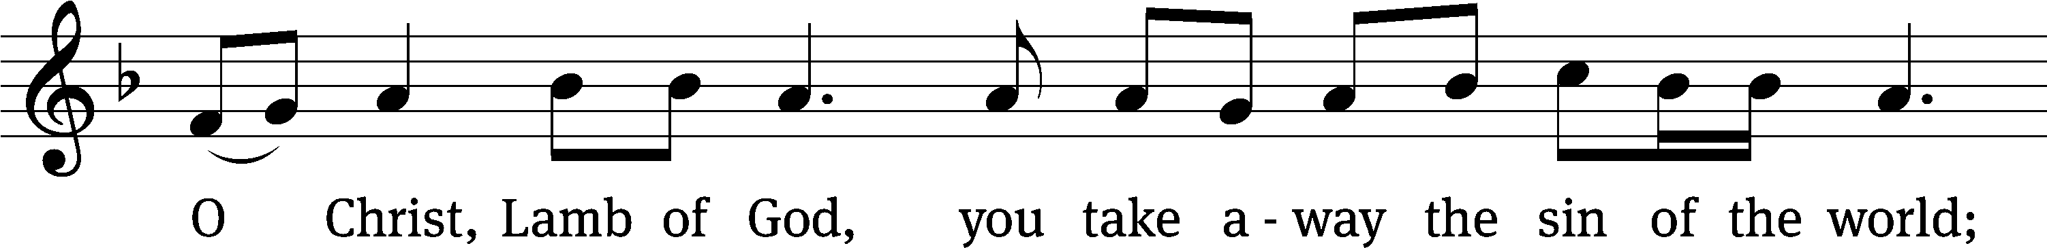
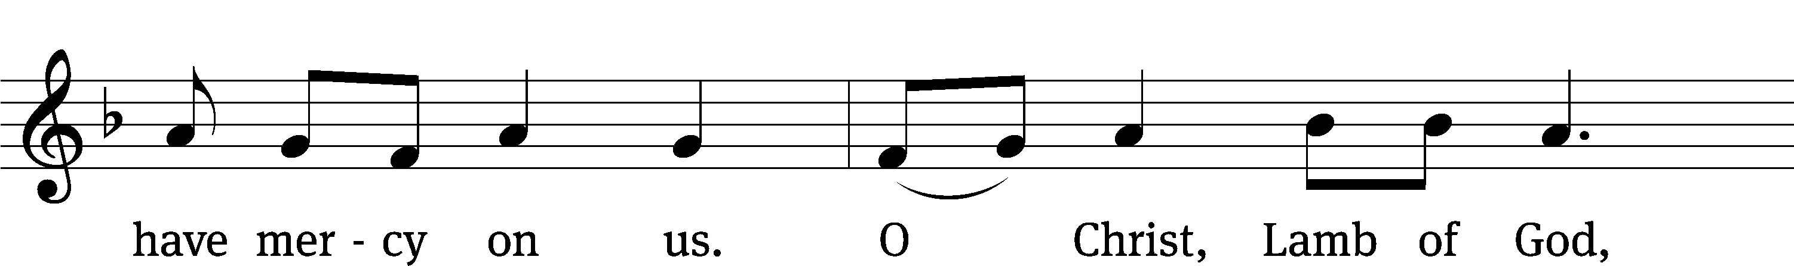
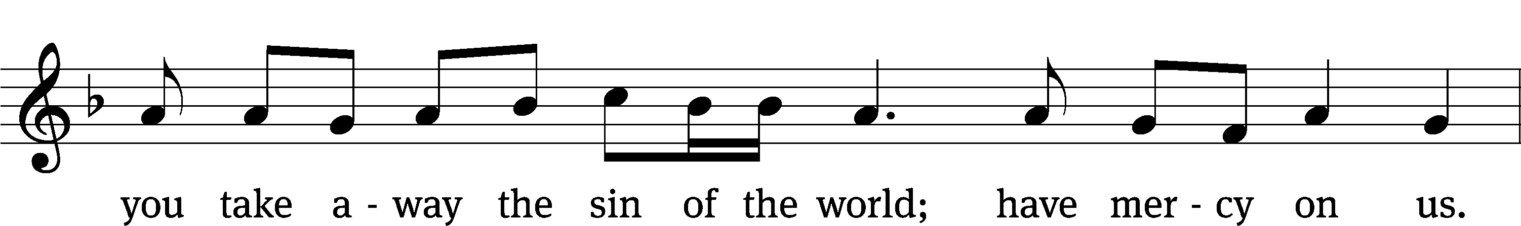
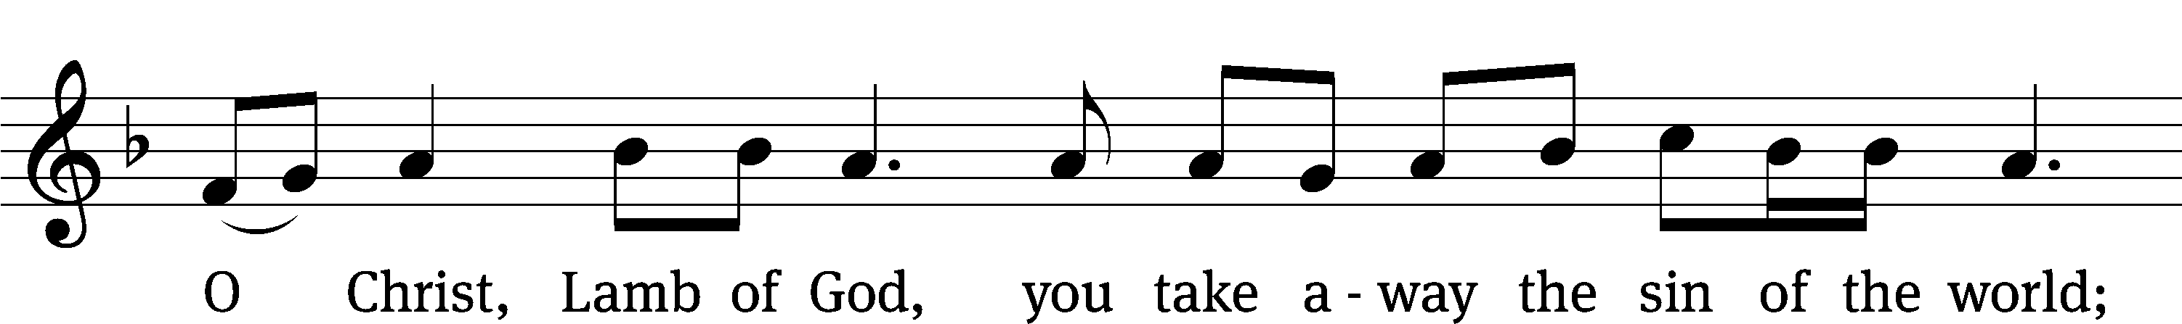
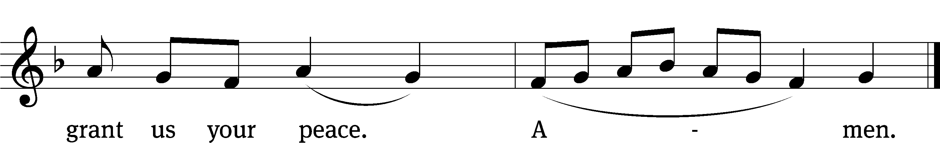

DISTRIBUTION
Those who will be receiving Holy Communion today may wish to read Personal Preparation for Holy Communion, found on page 295 in the front section of the hymnal. This page helps us put into practice what the Bible encourages: “Everyone ought to examine themselves before they eat of the bread and drink from the cup.” (1 Corinthians 11:28)
Christ Lutheran Church confesses and practices the Biblical teaching of a Closed Communion. We ask that only members of the Wisconsin Synod [WELS] or the Evangelical Lutheran Synod [ELS] join us at the Lord’s Table. If you have questions concerning our communion practice, or would like to inquire about how you, too, can commune with us, please speak with the Pastor following the service.
During the Distribution, the congregation may join to sing Hymn 676:
Take and Eat

THE SONG OF SIMEON
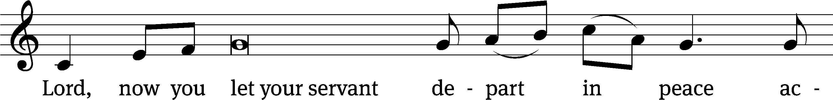
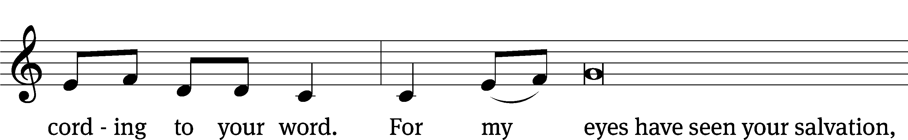
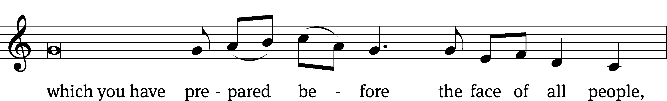
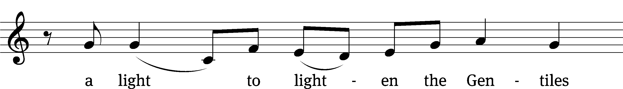
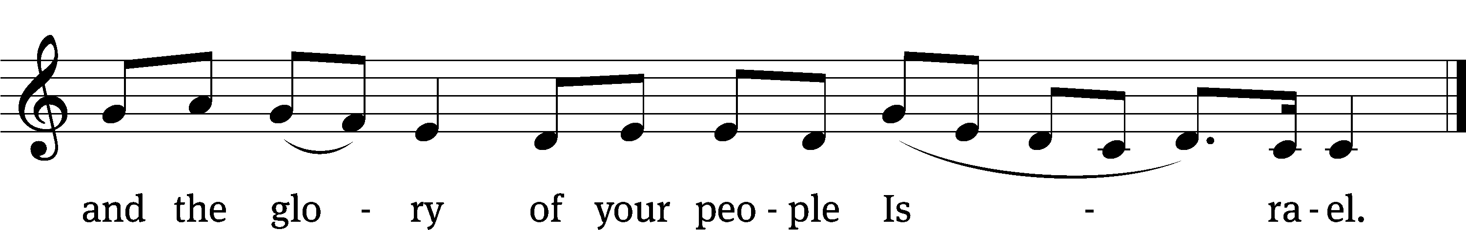
M: We give thanks, almighty God, that you have refreshed us with this holy supper. We pray that through it you will strengthen our faith in you and increase our love for one another. We ask this in the name of Jesus Christ, our Lord, who lives and reigns with you and the Holy Spirit, one God, now and forever.
C: Amen.

THE BLESSING
M: The Lord bless you and keep you.
The Lord make his face shine on you and be gracious to you.
The Lord look on you with favor and ✙ give you peace.
C: Amen.
CLOSING HYMN My Hope Is Built on Nothing Less| CW 563

COPYRIGHT INFORMATION
Content requiring a copyright license is reproduced under OneLicense.net #A-718312. All rights reserved. The Common Service: Texts revised from The Lutheran Hymnal, 1941. Music revised by James Engel. Scripture Quotations: From the Holy Bible, New International Version (NIV 1984), © 1973, 1978, 1984 by Biblica, Inc.

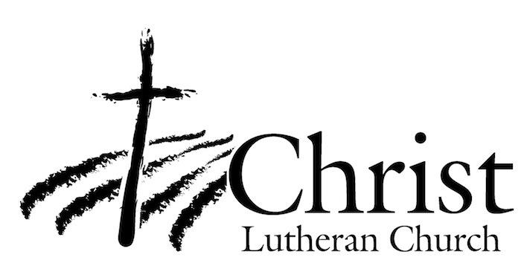
13009 N. Elderberry Ct.
Lodi, CA 95242
www.christlodi.org
209-368-6250
Pastor Timothy Leistekow
WELCOME TO CHRIST EV. LUTHERAN CHURCH!
We preach a message of forgiveness, hope and peace
through the death and resurrection of Jesus Christ.
Families and individuals of all ages will find opportunities
both to grow and to serve.
Our mission statement:
Look what Christ is doing!
He binds us together in fellowship
He gathers us in for worship
He builds us up for service
He sends us out with the gospel

“Now you are the body of Christ,
and each one of you is a part of it.”
(1 Corinthians 12:27)

